# Sorting Rows in a DataFrame

This document includes the question, the solution, and a breakdown of the code provided in the screenshot.

## Uploaded Screenshot

Below is the screenshot of the task:

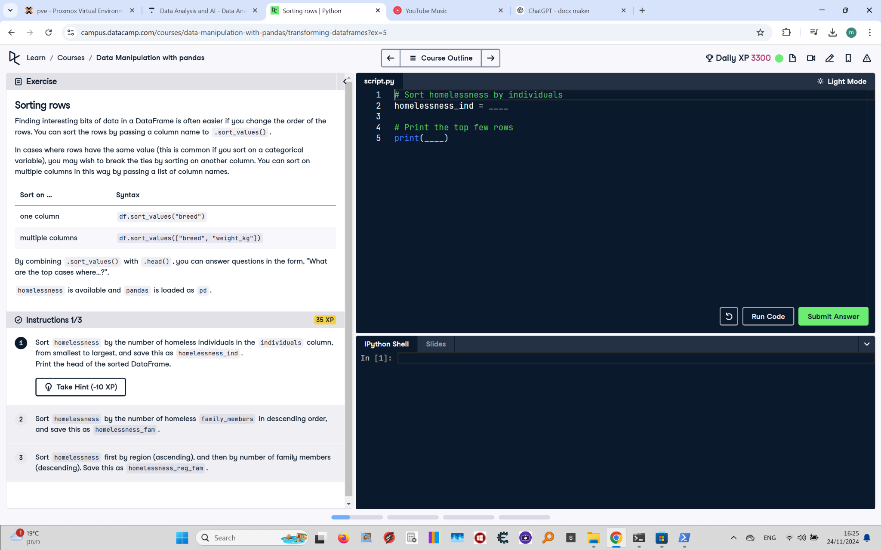

## Question

Sort the homelessness DataFrame by the number of individuals, from smallest to largest, and save this as `homelessness_ind`. Print the head of the sorted DataFrame.

## Answer

# Sort homelessness by individuals  
homelessness_ind = homelessness.sort_values("individuals")  
  
# Print the top few rows  
print(homelessness_ind.head())

## Code Explanation

# Explanation of the code:

1. `homelessness.sort_values("individuals")`: Sorts the `homelessness` DataFrame by the `individuals` column in ascending order by default.

2. `homelessness_ind`: Stores the sorted DataFrame for further use.

3. `print(homelessness_ind.head())`: Displays the first five rows of the sorted DataFrame to verify the sorting.